**NAMRATA PANDEY**

**ASSIGNMENT-02**

**Q.1 The challenges faced while implementing the software engineering?**

**Ans:** Business involves managing projects of all sizes and it involves lot of complexities. The same way, software development is no different. At every stage, there are number of problems and issues which are being encountered which can be described as follows:

1. The customer or the stakeholders are not sure about the requirements. This might be a hindrance in implementing the software engineering as they have basic idea of what they want in a software.
2. There can be a possibility that two different stakeholder specifies the what they want which contradicts each other. It might happen that single stakeholder may express certain requirements that are not aligned with the needs of another stakeholder.
3. Sometimes, the system can be so complex and difficult to understand and thus it gets really hard to implement software engineering.
4. When there is no defined set of requirements for the implementation, it effects the overall process. It might lead to higher implementation cost as well as a possibility that it might exceed the standard budget.
5. Many a times, there would not be proper documentation and budget constraints. This need to be taken care of as it really impacts the process of implementing software engineering.

**Q.2. What is the V-model?**

Ans: V-Model is a development process that may be considered as an extension of waterfall model. It is a type of SDLC model where there is a sequential way on how the process will be executed. Under this model the corresponding testing phase of the development phase is planned parallel. This means that there is a verification phases on one side of the V and there is Validation phase on the other side. It has various phases like design phase, testing phase.

It is very easy to use and is simple and it also allows for defect tracking. It is generally used for small projects where the requirements are clearly defined and is constant and where the technical resources are more with technical expertise. The phases in the V-Model are completed one at a time. Besides this, it is the model with higher or more risk and it does not involve iteration of the phases and is not efficient in handling the concurrent events that might occur.

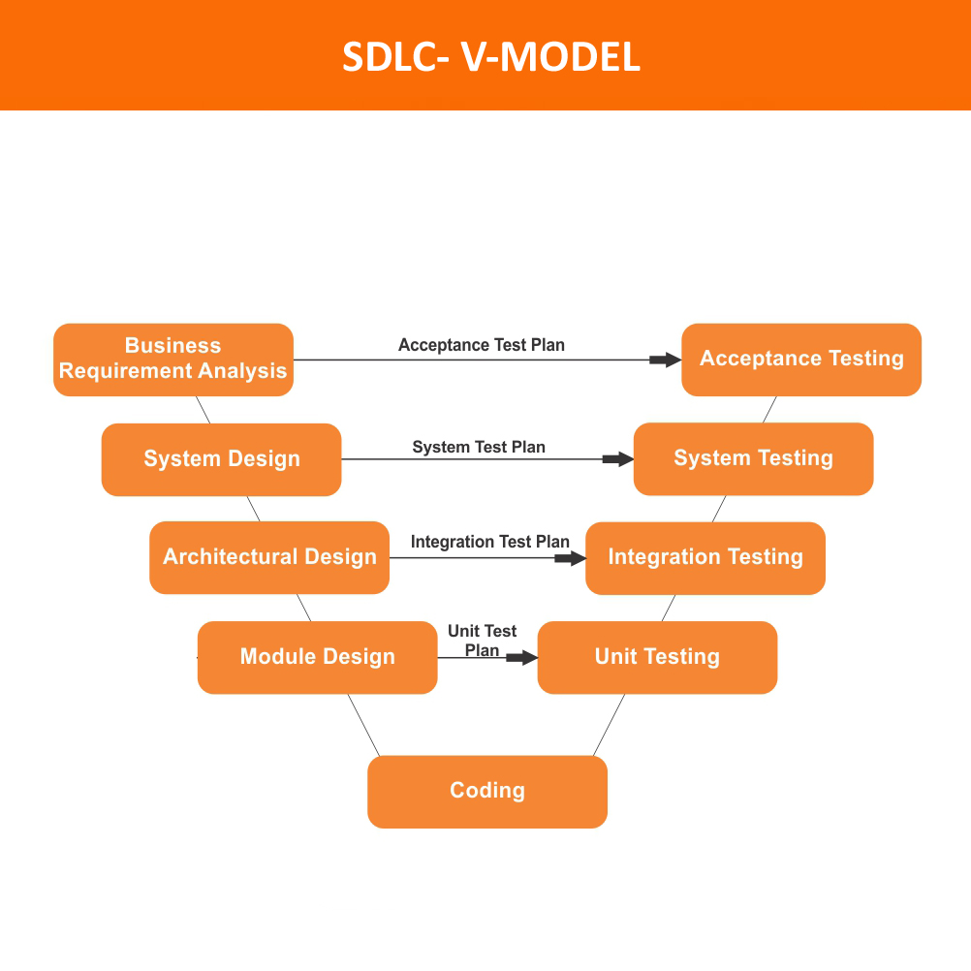

The image above shows the different phases of V-Model and how each phase works after the previous phase is done.

**Q.3 Who are stakeholders?**

**Ans:** Stakeholder is a party that has an interest in the company and can either affect or be affected by the business. The primary stakeholders in a company are investors, employees, customers and suppliers. In other words, a stakeholder is any person or entity that has an interest in the success or failure of a project or a business. They may have significant impact on decision making as regards to operation and the finances. In short, stakeholders can comprise a larger pool of entities than the traditional group of shareholders who actually owns a business. In Business analysis context, it the person who owns a product or a service.

**Q.4 What is the difference between product based and service-based company?**

**Ans: Product based Companies:** These are those companies which make the product which might be or might not be related to the software but they need IT expertise to make the product sellable. They are basically driven by an idea to help different customers and the main focus is to make the product better. Some of the examples are Microsoft, Google and yahoo. They fulfill product requirements of the general customers.

Some of the features of Product-Based companies are:

* Better flow of thoughts and healthy environment
* Less pressure and more job satisfaction
* The person doesn’t have to be multitasker but good in its respective field.

**Service Based Companies:** It is the company which provides software products and services in return for a price. In this, customer purchase the skill of a service provider and this type of business has strong emphasis on the client relationship and makes customer’s user. experience very important. Some of the examples are TCS, Infosys and Wipro. They fulfill software requirements for a client.

Some of the features of Service Based Companies are:

* High pressure work environment
* Meeting the deadlines is most important
* Multitasking is essentially required
* Scope of R&D is less